NAME: E.VAISHNAVI
REG NO: 1912260373
COURSE: ANALOG AND DIGITAL COMMUNICATION
CODE: ECA0801

EXP. NO: 18
MATLAB SIMULATION AND EVALUATION OF EYE DIAGRAM PARAMETERS UNDER INTER-SYMBOL INTERFERENCE IN DIGITAL COMMUNICATION SYSTEMS
Objectives :
1. To simulate a digital communication system in MATLAB and generate the eye diagram of the received signal for evaluating eye height, eye width, eye-crossing level and timing margin.
2. To introduce and study Inter-Symbol Interference (ISI) under different channel conditions, and evaluate its effect on eye-diagram opening and overall digital signal quality.
Procedure :
1. Open MATLAB and create a new script file.
2. Define the simulation parameters, including the number of bits and samples per symbol.
3. Generate a random binary data sequence using the randi() function.
4. Encode the binary data into an NRZ (Non-Return-to-Zero) digital signal using the repelem() function.
5. Create a communication channel model by defining a low-pass FIR filter to introduce Inter Symbol Interference (ISI).
6. Pass the transmitted NRZ signal through the channel using the conv() function to obtain the received signal affected by ISI.
7. Generate a time axis for displaying the transmitted and received waveforms.
8. Plot the following signals using MATLAB:
• Original Binary Data
• Transmitted NRZ Signal
• Received Signal with ISI
9. Plot the eye diagram of the received signal using the eyediagram() function.
10. Observe the effect of ISI on the eye diagram by analyzing the eye opening, eye height, eye width, and timing jitter.
11. Interpret the eye diagram to evaluate the performance of the digital communication system under the influence of Inter-Symbol Interference.
12. Record the observations and draw conclusions regarding the impact of ISI on signal quality and communication system performance.
PROGRAM :
clc;
clear;
close all;
%% Parameters
N = 100;
% Number of bits sps = 20;
% Samples per symbol
%% Generate Random Binary Data
data = randi([0 1],1,N);
%% NRZ Encoding
tx = repelem(data,sps);
%% Time Axis
t = (0:length(tx)-1)/sps;
%% Introduce Inter-Symbol Interference (ISI)%
% Simple Low-Pass FIR Filter (Channel)%
h = [0.2 0.6 1 0.6 0.2];
% Received Signal with ISI
rx = conv(tx,h,'same');
%% Plot Results%%
figure;
subplot(4,1,1)
stairs(data,'LineWidth',1.5)
grid on
title('Original Binary Data')
xlabel('Bit Number')
ylabel('Bit')
ylim([-0.2 1.2])
subplot(4,1,2)
plot(t,tx,'LineWidth',1.5)
grid on
title('Transmitted NRZ Signal')
xlabel('Time')
ylabel('Amplitude')
ylim([-0.5 1.5])
subplot(4,1,3)
plot(t,rx,'r','LineWidth',1.2)
grid on
title('Received Signal with Inter-Symbol Interference (ISI)')
xlabel('Time')
ylabel('Amplitude')
subplot(4,1,4)
eyediagram(rx,2*sps)
title('Eye Diagram under ISI')
Output:
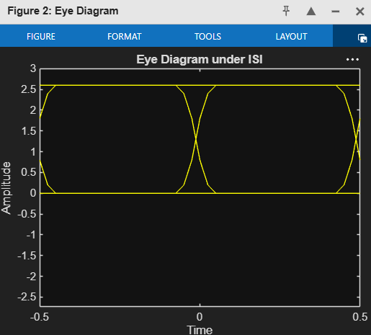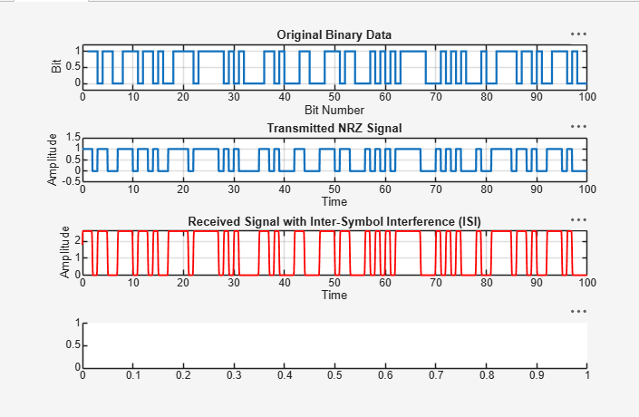
Result:
- Successfully generated an NRZ digital communication signal and transmitted it through a channel introducing Inter-Symbol Interference (ISI). The received signal exhibited pulse spreading and waveform distortion due to ISI, demonstrating its effect on signal quality.
- ii) Successfully plotted and analyzed the eye diagram of the received signal. The reduced eye opening, decreased eye height and eye width, and increased timing jitter confirmed the degradation in communication system performance caused by Inter-Symbol Interference (ISI).

EXP. NO: 22
SIMULATION AND ANALYSIS OF BPSK MODULATION USING CONSTELLATION DIAGRAMS IN MATLAB
Objectives:
1. To simulate Binary Phase Shift Keying (BPSK) modulation in MATLAB for a given binary data sequence.
2. To generate and analyze the BPSK constellation diagram and identify the two signal points corresponding to binary 0 and binary 1.
3. To study the effect of channel noise/AWGN on the BPSK constellation and evaluate signal quality using constellation parameters.
4. To compare the transmitted and detected symbols and determine the performance of the BPSK communication system.
Procedure:
1. Open the MATLAB software and create a new script file.
2. Clear the command window, workspace, and close all previously opened figure windows.
3. Generate a random binary data sequence.
4. Perform BPSK modulation by mapping the binary data into BPSK symbols.
5. Transmit the modulated signal through an Additive White Gaussian Noise (AWGN) channel.
6. Create a figure window to display the simulation results.
7. Plot the input binary data using a stem plot.
8. Plot the received BPSK symbols using a scatter plot to obtain the constellation diagram.
9. Label the axes appropriately and enable the grid for better visualization.
10. Execute the MATLAB program.
11. Observe the input binary sequence and the corresponding BPSK constellation diagram.
12. Analyze the distribution of the received symbols and verify the BPSK modulation characteristics.
PROGRAM:
Clc;
clear;
close all;
% Generate Random Bits
N = 100;
bits = randi([0 1],N,1);
% BPSK Modulation
bpsk = 2*bits - 1;
% 0 -> -1, 1 -> +1 % Add AWGN Noise
rx = awgn(bpsk,10,'measured');
% Constellation Diagram
figure;
subplot(2,1,1)
stem(bits)
title('Input Binary Data')
grid on
subplot(2,1,2)
scatter(real(rx), imag(rx),'filled')
title('BPSK Constellation Diagram')
xlabel('In-Phase')
ylabel('Quadrature')
grid on
axis([-2 2 -2 2])
Output:
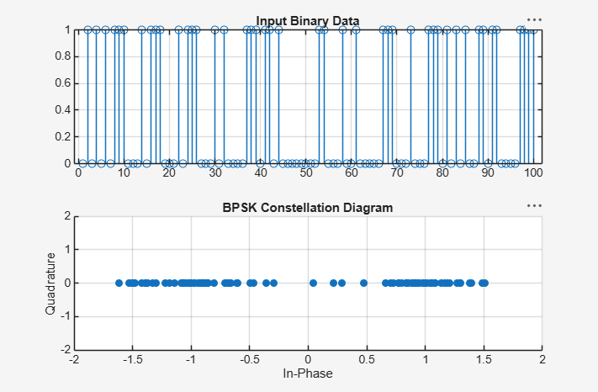
Result:
1. Generated a BPSK-modulated signal and its constellation diagram using MATLAB.
2. Identified the ideal BPSK constellation points and interpret their phase relationship.
3. Observed constellation spreading under AWGN/channel impairment.
4. Detected received BPSK symbols, compare them with transmitted symbols, and evaluate BER or symbol errors.

EXP. NO: 23
PERFORMANCE EVALUATION OF 8-QAM AND 16-QAM COMMUNICATION SYSTEMS UNDER AWGN USING BER, CONSTELLATION AND EYE DIAGRAM ANALYSIS IN MATLAB
Objectives:
1. To generate random binary data and implement 8-QAM and 16-QAM digital modulation in MATLAB.
2. To transmit the modulated signals through an Additive White Gaussian Noise (AWGN) channel for selected SNR/Eb/N0 conditions.
3. To evaluate the bit error rate (BER) performance of 8-QAM and 16-QAM and compare the measured results with the expected trend.
4. To plot and interpret the constellation diagrams of 8-QAM and 16-QAM under different noise conditions.
5. To generate and analyze eye diagrams to observe the effect of AWGN on signal quality and symbol/decision margins.
6. To compare the performance of 8-QAM and 16-QAM in terms of spectral efficiency, BER, constellation separation and eye opening.
Procedure:
1. Open the MATLAB software and create a new script file.
2. Clear the command window, workspace, and close all previously opened figure windows.
3. Generate a random binary data sequence.
4. Group the binary data into symbols and perform M-QAM modulation.
5. Transmit the modulated signal through an Additive White Gaussian Noise (AWGN) channel.
6. Demodulate the received M-QAM signal.
7. Compute the Bit Error Rate (BER) by comparing the transmitted and received binary data.
8. Display the transmitted and received constellation diagrams.
9. Generate the eye diagram of the received signal.
10. Execute the MATLAB program.
11. Observe the BER, constellation diagram, and eye diagram.
12. Analyze the communication system performance based on the BER value, constellation distribution, and eye opening.
PROGRAM :
clc;
clear;
close all;
% Parameters
M = 16; % 16-QAM
N = 1000; % Number of symbols
data = randi([0 M-1],N,1);
% QAM Modulation
tx = qammod(data,M,'UnitAveragePower',true);
% AWGN Channel
rx = awgn(tx,10,'measured'); % 10 dB SNR
% Demodulation
data_rx = qamdemod(rx,M,'UnitAveragePower',true);
% BER Calculation
[num, ber] = biterr(data,data_rx);
% Display BER
fprintf('Bit Error Rate (BER) = %f\n',ber);
% Eye Diagram Signal
eyeSig = repelem(real(rx),8);
% Plots
figure;
subplot(2,2,1)
scatter(real(tx),imag(tx),'filled')
title('16-QAM Transmitted Constellation')
grid on
subplot(2,2,2)
scatter(real(rx),imag(rx),'filled')
title('Received Constellation (AWGN)')
grid on
subplot(2,2,[3 4])
eyediagram(eyeSig,16)
title('Eye Diagram')
Output:
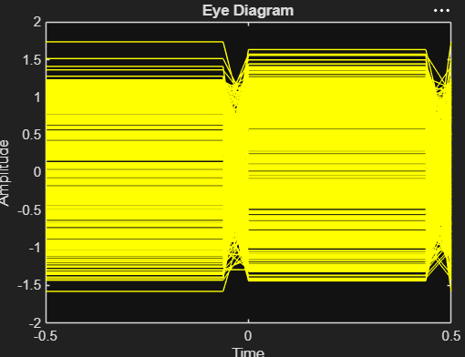
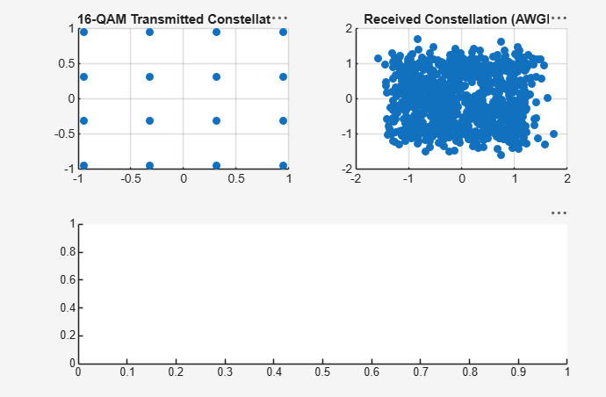
Result:
- Implemented 8-QAM and 16-QAM modulation and demodulation in MATLAB
2. Evaluated BER for different SNR/Eb/N0 values and interpret BER curves.
3. Analyzed constellation diagrams and identify the effect of AWGN on symbol dispersion.
4. Generated and interpret eye diagrams as a visual measure of signal quality.
5. Compared 8-QAM and 16-QAM based on BER, constellation quality and eye opening.
EXP. NO: 24
MATLAB SIMULATION OF PASSBAND TRANSMISSION WITH BER ANALYSIS UNDER MULTIPATH FADING CHANNELS
Objectives :
1. To simulate a digital passband communication system using MATLAB and study transmission through a multipath fading channel.
2. To generate a digitally modulated passband waveform, transmit it through a multipath fading channel, and recover the received data.
3. To evaluate system performance using Bit Error Rate (BER) under different signal-to-noise ratio (SNR) conditions.
4. To analyze the effect of multipath propagation, delay spread, fading, and additive noise on the received signal and BER performance.
5. To plot and interpret BER versus SNR characteristics and compare the simulated results with the expected communication-system behavior.
Procedure:
1. Open the MATLAB software and create a new script file.
2. Clear the command window, workspace, and close all previously opened figure windows.
3. Generate a random binary data sequence.
4. Perform BPSK modulation to obtain the passband transmitted signal.
5. Model the multipath fading channel.
6. Add noise to the faded signal.
7. Receive the transmitted signal through the multipath fading channel.
8. Demodulate the received signal and recover the transmitted binary data.
9. Calculate the Bit Error Rate (BER) by comparing the transmitted and detected binary sequences.
10. Display the transmitted signal, received signal, and BER comparison results.
11. Execute the MATLAB program.
12. Observe the effect of multipath fading on the received signal and analyze the BER performance.

PROGRAM :
clc;
clear;
close all;
% Parameters
N = 1000;
bits = randi([0 1],N,1);
% BPSK Modulation
tx = 2*bits - 1;
% Multipath Fading Channel
h = [1 0.5 0.3];
fade = filter(h,1,tx);
% Add AWGN
rx = awgn(fade,10,'measured');
% Detection
bits_rx = rx > 0;
% BER Calculation
[~, BER] = biterr(bits,bits_rx);
fprintf('BER = %f\n',BER);
% Plots
figure;
subplot(3,1,1)
plot(tx)
title('Transmitted BPSK Signal')
grid on
subplot(3,1,2)
plot(rx)
title('Received Signal (Multipath + AWGN)')
grid on
subplot(3,1,3)
stem(bits(1:50),'b')
hold on
stem(bits_rx(1:50),'r')
title(['BER = ' num2str(BER)])
legend('Original','Detected')
grid on
Output:
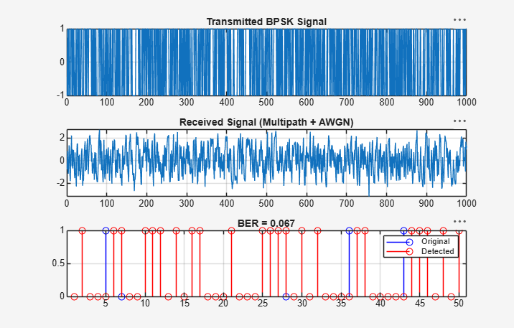
Result:
- The passband transmission system was successfully simulated in MATLAB, and the transmitted signal was recovered after propagation through the multipath fading channel.
- The Bit Error Rate (BER) analysis demonstrated the impact of multipath fading and channel noise on communication performance, indicating that increased fading and noise result in higher transmission errors.

EXP. NO: 25
SIMULATION OF CONVOLUTIONAL CODES AND ANALYSIS OF ENCODED OUTPUT BIT SEQUENCES USING MATLAB
Objectives:
1. To generate a binary information sequence and encode it using a convolutional encoder in MATLAB.
2. To understand the relationship between the input bit sequence, encoder memory, code rate, and encoded output sequence.
3. To analyze the structure and length of the encoded output bit sequence for a selected convolutional code.
4. To visualize and interpret the input and encoded bit sequences and verify the encoding operation.
5. To study the effect of encoder parameters such as constraint length and generator polynomials on the encoded sequence.
Procedure:
1. Open the MATLAB software and create a new script file.
2. Clear the command window, workspace, and close all previously opened figure windows.
3. Generate a random binary input sequence.
4. Define the convolutional encoder parameters.
5. Encode the input binary sequence using the convolutional encoder.
6. Store the encoded output bit sequence.
7. Display the input bit sequence using an appropriate plot.
8. Display the encoded output bit sequence using an appropriate plot.
9. Execute the MATLAB program.
10. Observe the input and encoded output bit sequences.
11. Compare the input and encoded sequences.
12. Analyze the encoding process and verify the correctness of the generated encoded output.

PROGRAM :
clc;
clear;
close all;
% Input Bits
data = randi([0 1],20,1);
% Convolutional Encoder (Rate 1/2, Constraint Length = 3)
trellis = poly2trellis(3,[7 5]);
encoded = convenc(data,trellis);
% Display
disp('Input Bits:');
disp(data');
disp('Encoded Bits:');
disp(encoded');
% Plot
figure;
subplot(2,1,1)
stem(data,'filled')
title('Input Bit Sequence')
xlabel('Bit Index')
ylabel('Bit Value')
grid on
subplot(2,1,2)
stem(encoded,'filled')
title('Convolutionally Encoded Bit Sequence')
xlabel('Bit Index')
ylabel('Bit Value')
grid on
Output:
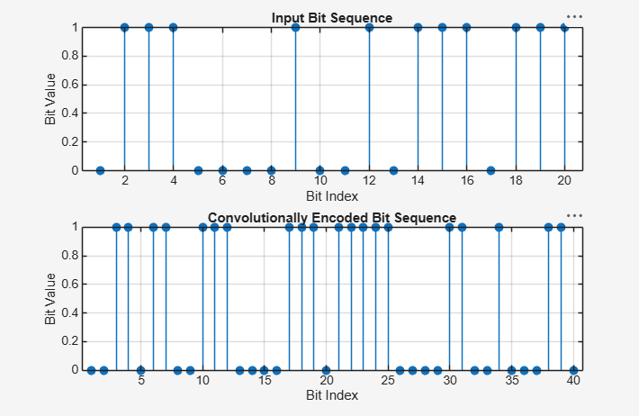

Result:
- The convolutional encoding process was successfully implemented in MATLAB, and the corresponding encoded output bit sequence was generated from the input binary sequence.
- ii) The comparison of the input and encoded bit sequences verified the correct operation of the convolutional encoder and demonstrated the introduction of redundancy for improving error correction capability.

EXP. NO: 26
MATLAB SIMULATION OF SINGLE-BIT ERROR DETECTION DATE: AND CORRECTION USING SYNDROME VECTORS IN LINEAR BLOCK CODES
Objectives :
- To simulate single-bit error detection and correction using syndrome vector decoding in a linear block coding scheme with MATLAB.
- To analyze the encoding, error detection, syndrome computation, and correction process by comparing the transmitted, received, and corrected codewords.

Procedure:
1. Open the MATLAB software and create a new script file.
2. Clear the command window, workspace, and close all previously opened figure windows.
3. Define the message bit sequence.
4. Generate the corresponding codeword using a linear block encoder.
5. Introduce a single-bit error into the encoded codeword.
6. Compute the syndrome vector using the parity-check matrix.
7. Identify the error location from the syndrome vector.
8. Correct the detected error in the received codeword.
9. Recover the original message from the corrected codeword.
10. Display the encoded codeword, received codeword, and corrected message.
11. Plot the encoded and received codewords for comparison.
12. Verify that the corrected message matches the original transmitted message.
PROGRAM :
clc;
clear;
close all;
% (7,4) Hamming Code
msg = [1 0 1 1];
% Encode
code = encode(msg,7,4,'hamming/binary');
% Introduce Single-Bit Error
rx = code;
rx(3) = ~rx(3); % Flip one bit %
Decode and Correct Error
dec = decode(rx,7,4,'hamming/binary');
% Display Results
disp('Message Bits:')
disp(msg)
disp('Encoded Bits:')
disp(code)
disp('Received Bits (with error):')
disp(rx)
disp('Corrected Message:')
disp(dec)
% Plot
figure;
subplot(2,1,1)
stem(code,'filled')
title('Encoded Codeword')
grid on
subplot(2,1,2)
stem(rx,'filled')
title('Received Codeword with Single-Bit Error')
grid on
Output:

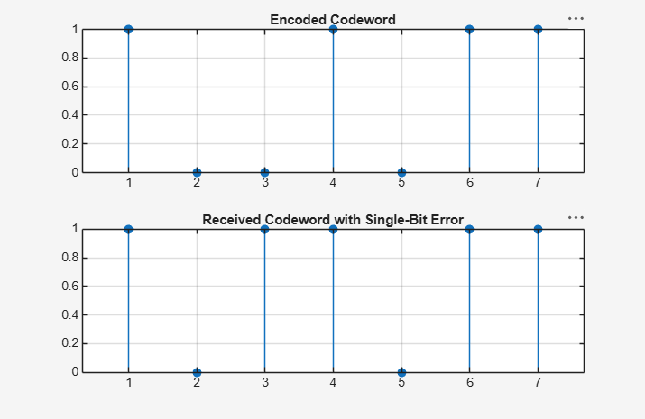
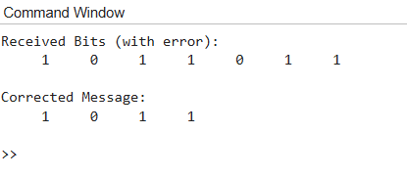
Result:
- The single-bit error detection and correction process using syndrome vectors was successfully implemented in MATLAB, and the introduced error was correctly identified and corrected.
- The comparison of the encoded, received, and corrected codewords confirmed the effectiveness of linear block codes in detecting and correcting single-bit transmission errors.
EX NO: 27
CALCULATION OF PROCESSING GAIN AND GENERATION OF PN SEQUENCES FOR SPREAD SPECTRUM COMMUNICATION USING MATLAB SIMULATION
Objectives:
1. To generate a pseudo-noise (PN) sequence using MATLAB for spread spectrum communication.
2. To determine the processing gain from the spreading factor or chip-to-bit ratio.
3. To perform spreading of a binary data sequence using the generated PN sequence.
4. To observe and analyze the characteristics of the generated PN sequence and spread signal.
5. To verify the relationship between processing gain, spreading factor, and bandwidth expansion.
6. To develop MATLAB-based skills for analyzing basic spread spectrum parameters.
Procedure :
1. Open the MATLAB software and create a new script file.
2. Clear the command window, workspace, and close all previously opened figure windows.
3. Define the required communication system parameters.
4. Calculate the processing gain of the spread spectrum system.
5. Generate a Pseudo Noise (PN) sequence.
6. Display the generated PN sequence in the MATLAB command window.
7. Plot the PN sequence using an appropriate plotting function.
8. Label the axes and provide an appropriate title for the plot.
9. Execute the MATLAB program.
10. Observe the calculated processing gain and the generated PN sequence.
11. Analyze the distribution of the PN sequence.
12. Verify that the generated sequence exhibits pseudo-random characteristics suitable for spread spectrum communication.

Program:
clc;
clear;
close all;
% Processing Gain
Rb = 1000; % Data Rate (bps)
Rc = 10000; % Chip Rate (chips/s)
PG = Rc/Rb;
PG_dB = 10*log10(PG);
fprintf('Processing Gain = %.2f\n', PG);
fprintf('Processing Gain (dB) = %.2f dB\n', PG_dB);
% Generate PN Sequence
% 31-bit PN sequence pn = randi([0 1],1,31);
% Display
disp('PN Sequence:');
disp(pn);
% Plot
figure;
stem(pn,'filled');
title('Pseudo Noise (PN) Sequence');
xlabel('Chip Number');
ylabel('Chip Value');
grid on;
Output:
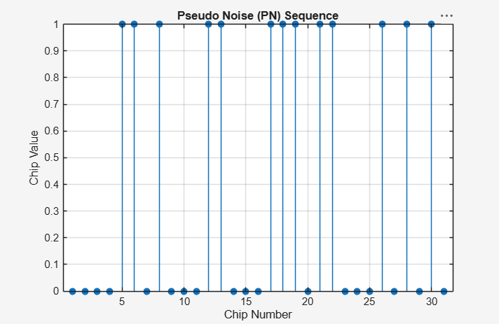
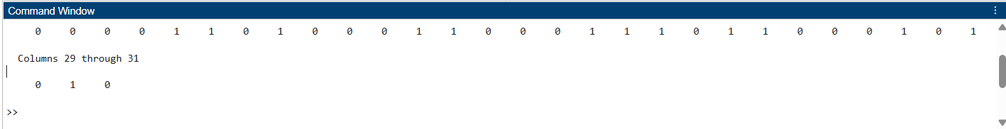
Result:
- The processing gain of the spread spectrum communication system was successfully calculated, and the corresponding PN sequence was generated using MATLAB.
- ii) The generated PN sequence exhibited pseudo-random characteristics, demonstrating its suitability for signal spreading and interference reduction in spread spectrum communication systems.

EX NO: 28
SIMULATION OF DSSS COMMUNICATION SYSTEM WITH PN CODE GENERATION AND SIGNAL RECOVERY USING MATLAB
Objectives:
- To simulate a Direct Sequence Spread Spectrum (DSSS) communication system by generating a Pseudo Noise (PN) sequence and spreading the input data using MATLAB.
- ii) To recover the transmitted data using the same PN sequence and analyze the effectiveness of the DSSS communication system.
Procedure :
1. Open the MATLAB software and create a new script file.
2. Clear the command window, workspace, and close all previously opened figure windows.
3. Define the input binary data sequence.
4. Generate a Pseudo Noise (PN) sequence.
5. Spread the input data using the generated PN sequence.
6. Transmit the spread signal through the communication channel.
7. Recover the transmitted signal using the same PN sequence.
8. Extract the original data from the recovered signal
9. Display the original data, DSSS spread signal, and recovered data.
10. Plot the original data, spread signal, and recovered data using appropriate plotting functions.
11. Execute the MATLAB program. Compare the original and recovered data to verify successful signal recovery.

Program:
clc;
clear;
close all;
% Data Bits
data = [1 0 1 1 0];
data = 2*data - 1;
% Convert to ±1 % PN Sequence (Length = 5)
pn = [1 -1 1 -1 1];
% DSSS Spreading
spread = kron(data,pn);
% Despreading
rec = reshape(spread,length(pn),[]);
rec_data = sign(sum(rec));
rec_data = (rec_data+1)/2; % Convert back to binary
% Display
disp('Original Data:');
disp((data+1)/2);
disp('Recovered Data:');
disp(rec_data);
% Plots
figure;
subplot(3,1,1)
stem((data+1)/2,'filled')
title('Original Data')
grid on
subplot(3,1,2)
stem(spread,'filled')
title('DSSS Spread Signal')
grid on
subplot(3,1,3)
stem(rec_data,'filled')
title('Recovered Data')
grid on

Output:
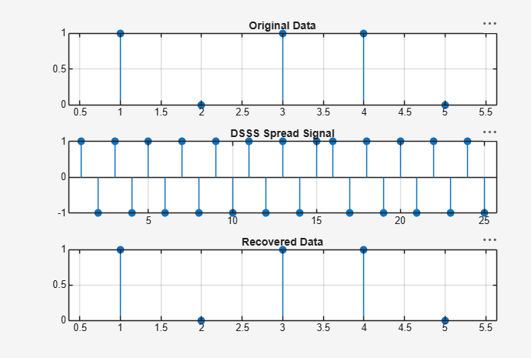
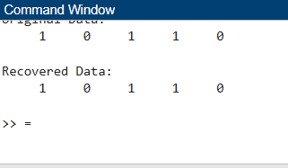
Result:
- The DSSS communication system was successfully simulated in MATLAB by generating a PN sequence, spreading the input data, and recovering the transmitted information.
- ii) The comparison of the original and recovered data confirmed the correct operation of the DSSS system and demonstrated the effectiveness of PN-code-based spreading and despreading techniques.

EX NO: 29
SIMULATION AND ANALYSIS OF GSM COMMUNICATION SYSTEM WITH TIME DIVISION MULTIPLE ACCESS (TDMA) USING MATLAB
Objectives:
1. To simulate the operation of a GSM communication system using Time Division Multiple To understand the basic structure of a GSM communication system and the role of Time Division Multiple Access (TDMA).
2. To generate a digital information sequence and organize it into GSM-style time slots using MATLAB.
3. To construct a simplified GSM/TDMA frame by assigning users to different time slots. 4. To simulate transmission, reception, slot extraction and recovery of the intended user data.
5. To observe the effect of slot allocation on multiple-access operation and verify that users can share the same carrier in different time slots.
6. To calculate and analyze important TDMA parameters such as number of slots, slot duration, frame duration and duty cycle.
Procedure:
1. Open the MATLAB software and create a new script file.
2. Clear the command window, workspace, and close all previously opened figure windows.
3. Define the binary data sequence to be transmitted.
4. Create a GSM TDMA frame by assigning the binary data to the available time slots.
5. Generate the corresponding TDMA signal.
6. Display the generated TDMA frame in the MATLAB command window.
7. Plot the GSM TDMA frame using an appropriate plotting function.
8. Plot the corresponding TDMA signal.
9. Label the axes and provide suitable titles for the plots.
10. Execute the MATLAB program.
11. Observe the generated TDMA frame and the corresponding TDMA signal.
12. Analyze the allocation of bits to time slots and verify the correct formation of the GSM TDMA frame.
PROGRAM :
clc;
clear;
close all;
% Four GSM Users
u1 = [1 0 1 1];
u2 = [0 1 0 1];
u3 = [1 1 0 0];
u4 = [0 0 1 1];
% TDMA Frame
tdma = [u1 u2 u3 u4];
% Display
disp('TDMA Frame:');
disp(tdma);
% Plot
figure;
subplot(2,1,1)
stem(tdma,'filled')
title('GSM TDMA Frame')
xlabel('Time Slot')
ylabel('Bit')
grid on
subplot(2,1,2)
stairs(tdma,'LineWidth',1.5)
title('TDMA Signal')
xlabel('Time Slot')
ylabel('Amplitude')
grid on
Output:
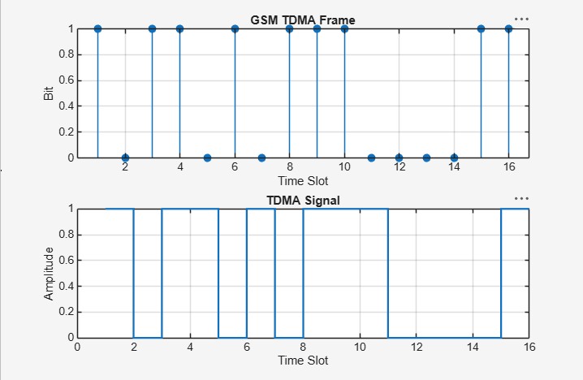

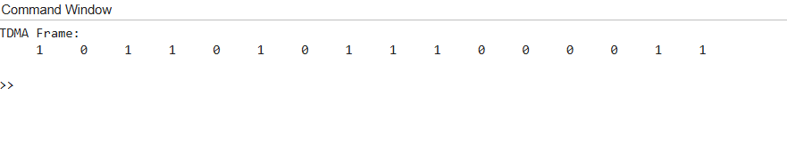

EXP NO: 30
ANALYSIS OF CELLULAR FREQUENCY PLANNING AND HANDOVER PERFORMANCE UNDER USER MOBILITY CONDITIONS USING MATLAB

Objectives:
- To understand the basic concept of cellular frequency planning and frequency reuse.
- To determine a suitable cellular cluster size and frequency-reuse factor for a simplified hexagonal cellular layout.
- To assign channel/frequency groups to cells and visualize the resulting reuse pattern.
- To model a mobile user moving through adjacent cells and calculate the received signal strength from serving and neighboring base stations. To identify handover conditions using a received-signal-strength comparison with a handover threshold and hysteresis margin.
- To measure and analyze handover locations, number of handovers, outage regions, and signal strength variation under user mobility.

Procedure:
1. Open the MATLAB software and create a new script file.
2. Clear the command window, workspace, and close all previously opened figure windows.
3. Define the positions of the cellular base stations.
4. Define the user movement along the cellular coverage area.
5. Determine the serving cell for each user position based on the nearest base station.
6. Record the cell association corresponding to each user location.
7. Display the user position and connected cell information.
8. Plot the handover performance showing the variation of connected cells with user movement.
9. Plot the cellular frequency planning indicating the locations of the base stations.
10. Execute the MATLAB program.
11. Observe the user mobility, connected cell transitions, and handover points.
12. Analyze the effectiveness of frequency planning and handover performance.

PROGRAM :
clc;
clear;
close all;
% Cell Centers (3 Cells)
cellPos = [0 500 1000];
% User Movement
user = 0:10:1000;
% Nearest Cell Selection (Handover)
handover = zeros(size(user));
for i = 1:length(user)
[~,handover(i)] = min(abs(user(i)-cellPos));
end
% Display
disp('User Position Connected Cell')
disp([user' handover'])
% Plot
figure;
subplot(2,1,1)
plot(user,handover,'b','LineWidth',2)
title('Handover Performance')
xlabel('User Position (m)')
ylabel('Cell Number')
grid on
subplot(2,1,2)
stem(cellPos,[1 2 3],'filled')
hold on
plot(user,ones(size(user))*2,'r--')
title('Cellular Frequency Planning')
xlabel('Distance (m)')
ylabel('Cell')
grid on

Output:
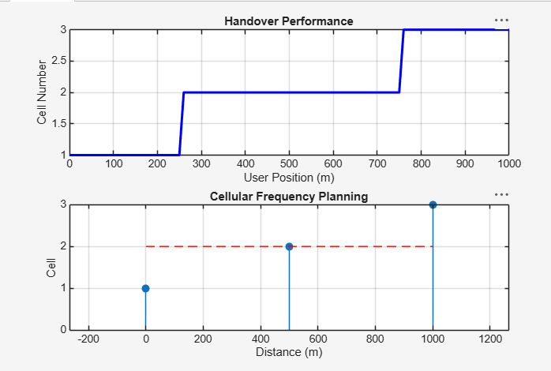
Result:
- The cellular frequency planning and handover process were successfully simulated in MATLAB, and the serving cell was identified for different user locations.
- +

- The simulation demonstrated successful handovers as the user moved across adjacent cells, validating the effectiveness of cellular frequency planning under user mobility conditions.

EXP NO: 2
CHARACTERISTICS STUDY OF SIDE BAND POWER AND FREQUENCIES IN AM USING MATLAB
Objectives:
- To generate an Amplitude Modulated (AM) signal in MATLAB using specified carrier and modulating signal parameters.
- To determine and verify the upper sideband (USB) and lower sideband (LSB) frequencies of the AM signal using frequency spectrum analysis in MATLAB.
- To calculate the carrier power, sideband power, and total transmitted power of the AM signal for a given modulation index using MATLAB.
- To analyze the effect of varying the modulation index on sideband power distribution and overall transmission efficiency through MATLAB simulation.
Objective 1:
To generate an Amplitude Modulated (AM) signal in MATLAB using specified carrier and modulating signal parameters
Procedure :
1. Open MATLAB and create a new script for AM signal generation and analysis.
2. Specify the sampling frequency, carrier frequency, modulating frequency, carrier amplitude and modulation index.
3. Generate the modulating signal using, m(t)=Am cos(2πfm t)
4. Generate the carrier signal using, c(t)=Ac cos(2πfc t)
5. Generate the AM signal using, s(t)=Ac [1+mcos(2πfm t)]cos(2πfc t).
6. Plot the modulating signal, carrier signal and AM signal in the time domain.
7. Calculate the theoretical frequencies of the lower and upper sidebands.
8. Obtain the frequency spectrum of the AM signal using MATLAB FFT analysis.
9. Identify the carrier, LSB and USB peaks from the frequency spectrum.
10. Verify the theoretically calculated frequencies with the frequencies observed from the MATLAB spectrum.
11. Calculate the carrier power using the specified load resistance.
12. Calculate the power contained in each sideband and the total transmitted power.
13. Calculate the transmission efficiency for the selected modulation index.
14. Repeat the simulation for different modulation-index values such as m=0.2, 0.5, 0.8 and 1.0.
15. Observe the change in sideband power and transmission efficiency as the modulation index is varied.
16. Record the results and compare the theoretical and MATLAB-simulated values.
PROGRAM :
clc;
clear;
close all;
Am=1;
fm=500;
Ac=5;
fc=5000;
fs=20*fc;
t=0:1/fs:4/fm;
m = Am*sin(2*pi*fm*t);
c = Ac*sin(2*pi*fc*t);
mu = Am/Ac;
am = Ac*(1+mu*sin(2*pi*fm*t)).*sin(2*pi*fc*t);
dem = abs(hilbert(am)); dem = dem-mean(dem);
N=length(am); f=linspace(-fs/2,fs/2,N); AM_FFT=abs(fftshift(fft(am)))/N;
USB=fc+fm; LSB=fc-fm;
Pc=Ac^2/2; Psb=(mu^2*Pc)/4;
figure('Name','AM Modulation','NumberTitle','off');
subplot(3,2,1), plot(t,m), title('Message'), grid on
subplot(3,2,2), plot(t,c), title('Carrier'), grid on
subplot(3,2,3), plot(t,am), title('AM Signal'), grid on
subplot(3,2,4), plot(t,dem), title('Demodulated'), grid on subplot(3,2,5), plot(f,AM_FFT), xlim([fc-3*fm fc+3*fm]), title('Sidebands'), grid on
subplot(3,2,6), bar([Pc Psb Psb]), set(gca,'XTickLabel',{'Carrier','USB','LSB'}), title('Power'), grid on fprintf('μ=%.2f | USB=%d Hz | LSB=%d Hz | Pc=%.2f W | Psb=%.3f W\n',mu,USB,LSB,Pc,Psb);
Output:
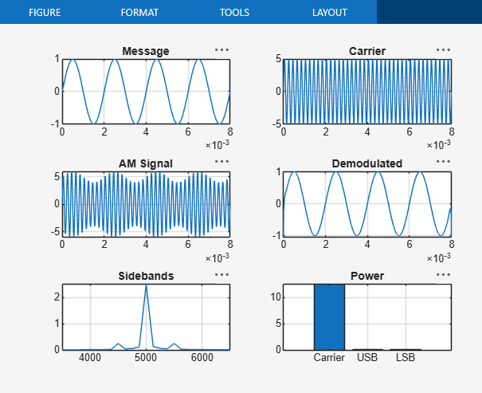
Result:
The AM signal was successfully generated and analyzed in
MATLAB.

EXP. NO: 3
MATLAB-BASED MODELLING OF VSB MODULATOR AND DEMODULATOR FOR ANALOG TELEVISION COMMUNICATION APPLICATIONS
Objectives:
- To generate and analyse the Vestigial Sideband (VSB) modulated signal by performing DSB-SC modulation and applying a suitable filter using MATLAB.
- To implement coherent demodulation and recover the original message signal from the VSB signal, and compare the transmitted and recovered waveforms.
Procedure :
1. Open MATLAB and create a new script file.
2. Define the simulation parameters such as sampling frequency, message frequency, carrier frequency, and time vector.
3. Generate the message signal using a low-frequency cosine waveform.
4. Generate the carrier signal using a high-frequency cosine waveform.
5. Perform DSB-SC modulation by multiplying the message signal with the carrier signal.
6. Design a Butterworth filter to approximate the Vestigial Sideband (VSB) filter.
7. Apply the VSB filter to the DSB-SC signal to obtain the VSB modulated signal.
8. Perform coherent demodulation by multiplying the VSB signal with a synchronized carrier signal.
9. Design and apply a low-pass filter to the demodulated signal to recover the original message signal.
10. Plot the message signal, carrier signal, DSB-SC signal, VSB signal, demodulated signal, and recovered message signal using MATLAB subplots.
11. Compare the recovered message signal with the original message signal to verify successful modulation and demodulation.
12. Analyze the simulation results and conclude the performance of the VSB modulation and demodulation process for analog television communication applications.
PROGRAM:
clc;
clear;
close all;
% Parameters
fs = 100000; % Sampling Frequency
t = 0:1/fs:0.02; % Time Vector
fm = 500; % Message Frequency
fc = 5000; % Carrier Frequency %
Message Signal
m = cos(2*pi*fm*t);
% Carrier Signal
c = cos(2*pi*fc*t);
% DSB-SC Modulation
dsb = m .* c;
% VSB Filter (Low-pass + High-pass Approximation)
[b,a] = butter(4, fc/(fs/2));
vsb = filter(b,a,dsb);
% Coherent Demodulation
demod = vsb .* (2*cos(2*pi*fc*t));
% Recover Message
[b1,a1] = butter(4, 1000/(fs/2));
rec = filter(b1,a1,demod);
% Display Results
figure;
subplot(5,1,1)
plot(t,m)
title('Message Signal')
grid on
subplot(5,1,2)
plot(t,c)
title('Carrier Signal')
grid on
subplot(5,1,3)
plot(t,dsb)
title('DSB-SC Signal')
grid on
subplot(5,1,4)
plot(t,vsb)
title('VSB Signal')
grid on
subplot(5,1,5)
plot(t,rec,'r')
title('Recovered Message')
grid on
Output:
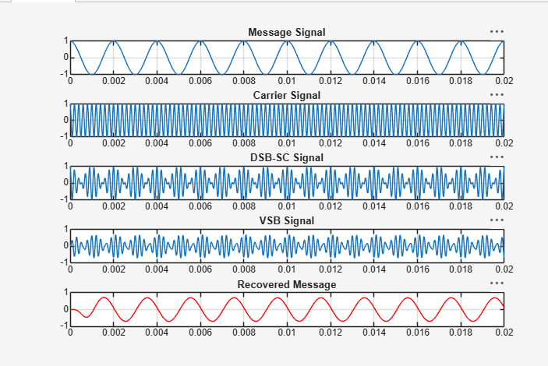Result:
- The VSB modulated signal was successfully generated from the DSB-SC signal using MATLAB and verified through the displayed waveforms.
- The original message signal was successfully recovered through coherent demodulation and low-pass filtering, confirming the correct implementation of the VSB communication system.

EXP. NO: 4
MATLAB SIMULATION OF SUPERHETERODYNE RECEIVER FOR AM COMMUNICATION SYSTEM WITH FREQUENCY MIXING AND FILTERING
Objectives:
- To model and simulate the operation of a superheterodyne receiver for an AM communication system using MATLAB by implementing frequency mixing and intermediate frequency (IF) signal generation.
- ii) To recover the original message signal through intermediate frequency filtering and envelope detection, and analyze the waveforms of the message, carrier, AM, IF, and recovered signals.
Procedure:
1. Open MATLAB and create a new script.
2. Enter carrier amplitude, carrier frequency, message amplitude, message frequency, sampling frequency and selected IF.
3. Generate the message signal.
4. Generate the RF carrier signal.
5. Generate the conventional AM signal.
6. Generate the local oscillator; for high-side injection use f_LO = f_RF + f_IF.
7. Multiply the AM/RF signal and local oscillator to perform frequency mixing.
8. Use FFT to identify the mixer sum and difference components.
9. Design an IF band-pass filter centred at f_IF and apply it to the mixer output. 10. Plot the filtered IF waveform and its spectrum.
11. Perform envelope detection on the filtered IF signal.
12. Apply a low-pass filter to recover the message.
13. Plot original and recovered messages together.
14. Compare message, carrier, AM, IF and recovered waveforms.
15. Calculate frequency deviation/error where required and record observations.

PROGRAM :
clc;
clear;
close all;
% Parameters
fs = 100000;
t = 0:1/fs:0.02;
fm = 500; % Message frequency
fc = 10000; % Carrier frequency
fLO = 14550; % Local Oscillator (IF = 4550 Hz)
% Message Signal
m = cos(2*pi*fm*t);
% Carrier Signal
c = cos(2*pi*fc*t);
% AM Signal
am = (1 + m).*cos(2*pi*fc*t);
% Local Oscillator
LO = cos(2*pi*fLO*t);
% Frequency
Mixing mixed = am .* LO;
% IF Filter
[b,a] = butter(4,5000/(fs/2));
IF = filter(b,a,mixed);
% Envelope Detection
env = abs(hilbert(IF));
% Display
figure;
subplot(4,1,1)
plot(t,m)
title('Message Signal')
grid on
figure;
subplot(5,1,2)
plot(t,c)
title('Carrier Signal')
grid on
subplot(5,1,3)
plot(t,am)
title('AM Signal')
grid on
subplot(5,1,4)
plot(t,IF)
title('Intermediate Frequency (IF) Signal')
grid on
subplot(5,1,5)
plot(t,env)
title('Recovered Signal')
grid on

Output:
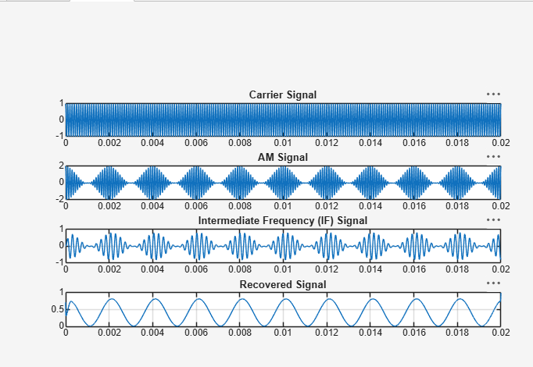
Result:
The superheterodyne receiver was successfully simulated in MATLAB, and the message signal, carrier signal, AM signal, Intermediate Frequency (IF) signal, and recovered signal were obtained through frequency mixing and filtering.

EXP. NO: 6
GENERATION AND ANALYSIS OF FREQUENCY MODULATED (FM) AND OF PHASE MODULATED (PM) SIGNALS USING MATLAB
Objectives:
To generate and analyze Frequency Modulated (FM) and Phase Modulated (PM) signals using MATLAB by varying the instantaneous frequency and phase of a carrier signal in accordance with the message signal.
Procedure:
1. Open MATLAB and create a new script file.
2. Define the simulation parameters, including the sampling frequency, time vector, message frequency, carrier frequency, message amplitude, and carrier amplitude.
3. Generate the message signal using a low-frequency sinusoidal waveform.
4. Generate the carrier signal using a high-frequency sinusoidal waveform.
5. Generate the Frequency Modulated (FM) signal by varying the instantaneous frequency of the carrier in accordance with the message signal and the selected frequency modulation index.
6. Generate the Phase Modulated (PM) signal by varying the instantaneous phase of the carrier according to the message signal and the selected phase modulation index.
7. Plot the message signal, carrier signal, FM signal, and PM signal using MATLAB subplots.
8. Observe and compare the time-domain waveforms of the FM and PM signals with the original message signal.
9. Analyze the variation in the instantaneous frequency of the FM signal and the instantaneous phase of the PM signal due to changes in the message signal.
10. Compare the characteristics of FM and PM signals by studying their modulation behavior and waveform variations.
11. Verify the successful generation of FM and PM signals based on the simulation results.

PROGRAM :
clc;
clear;
close all;
Am=1;
Ac=1;
fm=5;
fc=50;
beta=5;
kp=5;
fs=1000;
t=0:1/fs:1;
m = Am*cos(2*pi*fm*t); % Message signal
c = Ac*cos(2*pi*fc*t); % Carrier signal
fm_sig = Ac*cos(2*pi*fc*t + beta*sin(2*pi*fm*t)); % FM
pm_sig = Ac*cos(2*pi*fc*t + kp*m);
Df = beta*fm; % PM % Frequency deviation
fprintf('Frequency Deviation = %d Hz\n',Df);
fprintf('FM Modulation Index = %d\n',beta);
subplot(4,1,1), plot(t,m), title('Message Signal')
subplot(4,1,2), plot(t,c), title('Carrier Signal')
subplot(4,1,3), plot(t,fm_sig), title('FM Signal')
subplot(4,1,4), plot(t,pm_sig), title('PM Signal')

Output:
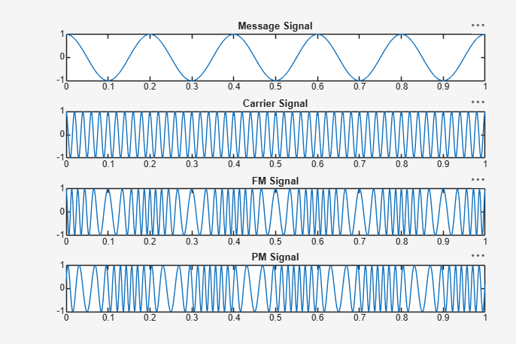
Result:
The Frequency Modulated (FM) and Phase Modulated (PM) signals were successfully generated using MATLAB by varying the instantaneous frequency and phase of the carrier signal according to the message signal. • Frequency Deviation (Δf) = 25 Hz • FM Modulation Index (β) = 5
EX NO: 7
CALCULATION AND VERIFICATION OF FREQUENCY DEVIATION AND MODULATION INDEX OF FM SIGNALS USING MATLAB SIMULATION
Objectives:
1. To generate a Frequency Modulated (FM) signal in MATLAB using specified carrier and message signal parameters.
2. To calculate and verify the frequency deviation of the FM signal from the given carrier frequency and modulating signal parameters.
3. To determine and verify the modulation index of the FM signal using the relationship between frequency deviation and message frequency.
4. To analyze the effect of message frequency on frequency deviation and modulation index, and verify their relationship through MATLAB simulation
Procedure:
1. Open MATLAB and create a new script file.
2. Clear the command window, workspace variables, and close all previously opened figure windows using: Clc; Clear; close all;
3. Define the message signal parameters:
● Message amplitude A_m=2V
● Message frequency f_m=500Hz 4. Define the carrier signal parameters:
● Carrier amplitude A_c=1V
● Carrier frequency f_c=10000Hz
5. Define the frequency sensitivity constant k_f, sampling frequency f_s, and simulation duration T
6. Generate the time vector using: t = 0:1/fs:T;
7. Generate the message signal using: m = Am*cos(2*pi*fm*t); and observe the sinusoidal waveform.
8. Calculate the frequency deviation of the FM signal using: Δf=kf. Am
9. Calculate the modulation index using: β=Δf/fm
10. Generate the FM signal using: fm_signal = Ac*cos(2*pi*fc*t + beta*sin(2*pi*fm*t)); where the carrier frequency varies according to the message signal.
11. Plot the message signal in the first subplot and label the axes appropriately.
12. Plot the FM signal in the second subplot and observe the variation in instantaneous frequency.
13. Display the carrier frequency, message frequency, message amplitude, and frequency sensitivity in the MATLAB command window using fprintf statements.
14. Display the calculated frequency deviation and modulation index values in the command window.
15. Verify the modulation index by recomputing it using: β=Δf/fm and compare the result with the previously calculated value.
16. Use a conditional statement (if-else) to check whether both modulation index values are equal within a small tolerance.
17. Display the verification result as:
● "Verification Successful" if both values match.
● "Verification Failed" otherwise.
18. Execute the MATLAB program and observe the message signal, FM signal, calculated frequency deviation, modulation index, and verification result.

PROGRAM :
% Calculation and Verification of Frequency Deviation
% and Modulation Index of FM Signal
clc;
clear;
close all;
%% Message Signal Parameters
Am = 2; % Message amplitude (V)
fm = 500; % Message frequency (Hz)
%% Carrier Signal Parameters
Ac = 1; % Carrier amplitude (V)
fc = 10000; % Carrier frequency (Hz)
%% FM Parameters
kf = 250; % Frequency sensitivity (Hz/V)
fs = 100000; % Sampling frequency (Hz)
T = 0.01; % Simulation duration (s)
%% Time Vector
t = 0:1/fs:T;
%% Message Signal
m = Am*cos(2*pi*fm*t);
%% Frequency Deviation
delta_f = kf*Am;
%% Modulation Index
beta = delta_f/fm;
%% FM Signal
fm_signal = Ac*cos(2*pi*fc*t + beta*sin(2*pi*fm*t));
%% Display Parameters
fprintf('Carrier Frequency (fc) = %.0f Hz\n',fc);
fprintf('Message Frequency (fm) = %.0f Hz\n',fm);
fprintf('Message Amplitude (Am) = %.0f V\n',Am);
fprintf('Frequency Sensitivity (kf) = %.0f Hz/V\n',kf);
fprintf('\nFrequency Deviation (Delta f) = %.2f Hz\n',delta_f);
fprintf('Modulation Index (Beta) = %.2f\n',beta);
%% Verification
beta_verify = delta_f/fm;
fprintf('Verified Modulation Index = %.2f\n',beta_verify);
%% Verification Check
tolerance = 1e-6;
if abs(beta - beta_verify) < tolerance
fprintf('\nVerification Successful\n');
else
fprintf('\nVerification Failed\n');
end
%% Plotting
figure;
subplot(2,1,1);
plot(t,m,'LineWidth',1.5);
grid on;
title('Message Signal');
xlabel('Time (s)');
ylabel('Amplitude (V)');
subplot(2,1,2);
plot(t,fm_signal,'LineWidth',1);
grid on;
title('FM Signal');
xlabel('Time (s)');
ylabel('Amplitude (V)');

Output:
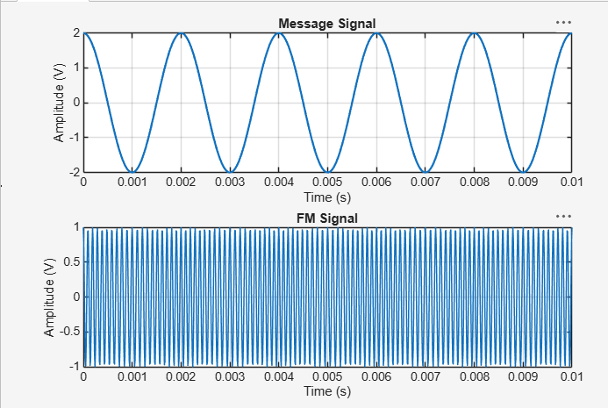
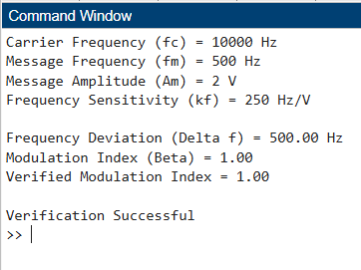
Result:
1. Generate and visualize carrier, message, and FM signals using MATLAB.
2. Calculate the theoretical frequency deviation and verify it from the simulated FM waveform.
3. Calculate the FM modulation index and verify the relationship β = Δf/fm.
4. Interpret the effect of changing message frequency on modulation index and verify that, for constant frequency sensitivity and message amplitude, the peak frequency deviation remains constant.

EX NO: 8
POWER SPECTRAL DENSITY (PSD) ANALYSIS OF PHASE MODULATED (PM) SIGNALS USING MATLAB
Objectives:
- To generate a Phase Modulated (PM) signal in MATLAB using specified carrier and message signal parameters.
- To compute the frequency spectrum of the PM signal using the Fast Fourier Transform (FFT).
- To calculate and plot the Power Spectral Density (PSD) of the PM signal using MATLAB.
- To identify the carrier component and sideband frequencies present in the PM spectrum.
- To analyze the effect of phase modulation on the spectral distribution and bandwidth of the transmitted signal.
- To investigate the influence of modulation index on the Power Spectral Density characteristics of the PM signal.

Procedure:
1. Open MATLAB and create a new script file.
2. Initialize the MATLAB workspace by clearing all variables, command window contents, and open figure windows using: clc; clear; close all;
3. Define the message signal amplitude (AmA_mAm), message frequency (fmf_mfm), carrier amplitude (AcA_cAc), carrier frequency (fcf_cfc), sampling frequency (fsf_sfs), and phase sensitivity constant (kpk_pkp).
4. Generate the time vector required for simulation.
5. Generate the message signal and carrier signal.
6. Generate the Phase Modulated (PM) signal using the PM equation.
7. Compute the Fast Fourier Transform (FFT) of the PM signal.
8. Calculate the Power Spectral Density (PSD) from the FFT results.
9. Generate the frequency axis corresponding to the FFT output.
10. Plot the message signal, PM signal, frequency spectrum, and PSD using MATLAB plotting commands.
11. Determine the carrier frequency component and sideband frequencies from the spectrum.
12. Display the phase deviation and estimated bandwidth using the MATLAB Command Window.
13. Analyze the PSD plot and observe the spectral distribution around the carrier frequency.
14. Record the observations and verify the characteristics of Phase Modulation in the frequency domain.

PROGRAM :
clc;
clear;
close all;
% Parameters
Am = 1; ; % Message Amplitude (V)
fm = 100; % Message Frequency (Hz)
Ac=5;% Carrier Amplitude (V)
fc = 1000; % Carrier Frequency (Hz
fs = 20*fc; % Sampling Frequency (Hz)
kp = pi/2; % Phase Sensitivity (rad/V)
% Time Vector
t = 0:1/fs:4/fm;
% Message Signal
m = Am*sin(2*pi*fm*t);
% PM Signal
pm = Ac*cos(2*pi*fc*t + kp*m);
% Phase Deviation
beta = kp*Am;
% FFT
N = length(pm);
f = linspace(-fs/2,fs/2,N);
PM_FFT = abs(fftshift(fft(pm)))/N;
% Power Spectral Density
PSD = (abs(fftshift(fft(pm))).^2)/(N*fs);
% Approximate Bandwidth
BW = 2*(beta+1)*fm;
fprintf('Phase Deviation = %.2f radians\n',beta);
fprintf('Estimated Bandwidth = %.2f Hz\n',BW);
% Plotting
figure('Name','PSD Analysis of PM Signal','NumberTitle','off');
subplot(2,2,1);
plot(t,m);
title('Message Signal');
xlabel('Time (s)'); ylabel('Amplitude');
grid on;
subplot(2,2,2);
plot(t,pm);
title('Phase Modulated Signal');
xlabel('Time (s)'); ylabel('Amplitude');
grid on;
subplot(2,2,3);
plot(f,PM_FFT);
title('Frequency Spectrum of PM Signal');
xlabel('Frequency (Hz)');
ylabel('Magnitude');
grid on;
subplot(2,2,4);
plot(f,PSD);
title('Power Spectral Density');
xlabel('Frequency (Hz)');
ylabel('PSD');
grid on;

Output:
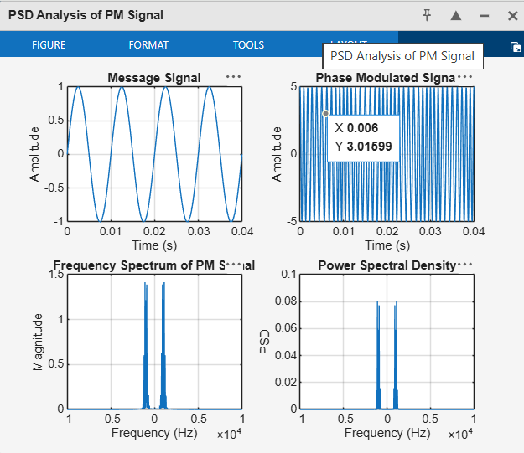
Result:
The Power Spectral Density (PSD) of the Phase Modulated (PM) signal was successfully obtained and analyzed using MATLAB.
- Message Frequency = 100 Hz
- Carrier Frequency = 1000 Hz
- Phase Deviation = 1.57 radians
- PM Modulation Index = 1.57
- Estimated Bandwidth = 514 Hz
- The PSD plot showed the carrier component and multiple sidebands around the carrier frequency, confirming the frequency-domain characteristics of Phase Modulation.

EXP. NO: 9
PERFORMANCE EVALUATION OF AM GENERATION AND DETECTION UNDER NOISY CHANNEL CONDITIONS USING MATLAB
Objectives:
- To generate an Amplitude Modulated (AM) signal, introduce Additive White Gaussian Noise (AWGN), and analyze the effect of noise on the transmitted signal using MATLAB.
- To recover the original message signal from the noisy AM signal using envelope detection and compare the transmitted and recovered waveforms to evaluate the performance of the AM communication system.

Procedure:
1. Open MATLAB and create a new script file.
2. Define the simulation parameters, including the sampling frequency, time vector, message frequency, carrier frequency, message amplitude, carrier amplitude, and Signal-to-Noise Ratio (SNR).
3. Generate the message signal using a low-frequency sinusoidal waveform.
4. Generate the carrier signal using a high-frequency sinusoidal waveform.
5. Generate the Amplitude Modulated (AM) signal by modulating the carrier signal with the message signal.
6. Introduce Additive White Gaussian Noise (AWGN) to the AM signal using the MATLAB awgn() function with the specified SNR.
7. Perform envelope detection on the noisy AM signal using the Hilbert transform to recover the original message signal.
8. Plot the message signal, carrier signal, AM signal, noisy AM signal, and recovered signal using MATLAB subplots.
9. Compare the original message signal with the recovered signal to observe the effect of AWGN on signal quality.
10. Analyze the performance of the AM communication system by studying the degradation caused by noise and the effectiveness of the envelope detector in recovering the message signal.
11. Verify the successful generation, transmission, and recovery of the AM signal under noisy channel conditions.

PROGRAM:
clc;
clear;
close all;
% Parameters
fs = 100000;
t = 0:1/fs:0.02;
fm = 500;
fc = 5000;
% Message Signal
m = cos(2*pi*fm*t);
c = cos(2*pi*fc*t);
% AM Modulation
am = (1 + m).*cos(2*pi*fc*t);
% Add AWGN Noise
noisy = awgn(am,10,'measured'); % 10 dB SNR
% Envelope Detection
env = abs(hilbert(noisy));
% Display Results
figure;
subplot(5,1,1)
plot(t,m)
title('Message Signal')
grid on
subplot(5,1,2)
plot(t,c)
title('Carrier Signal')
grid on
subplot(5,1,3)
plot(t,am)
title('AM Signal')
grid on
subplot(5,1,4)
plot(t,noisy)
title('AM Signal with AWGN Noise')
grid on
subplot(5,1,5)
plot(t,env)
title('Recovered Signal')
grid on

Output:
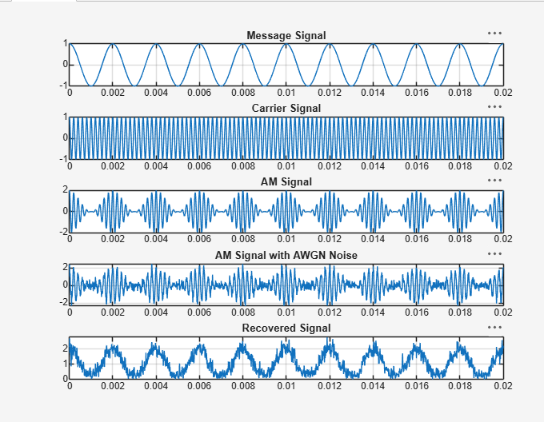
Result:
- The AM signal was successfully generated in MATLAB, and the effect of Additive White Gaussian Noise (AWGN) on the transmitted signal was observed through the noisy AM waveform.
- The original message signal was successfully recovered using envelope detection, demonstrating the effectiveness of the AM receiver in recovering the transmitted information in the presence of AWGN noise.

EXP. NO: 10
PERFORMANCE ANALYSIS OF FM SYSTEM UNDER GAUSSIAN WHITE NOISE USING MATLAB
Objectives :
1. To generate a Frequency Modulated (FM) signal in MATLAB using the specified carrier and message signal parameters.
2. To introduce Additive White Gaussian Noise (AWGN) into the generated FM signal and simulate the effect of a noisy communication channel using MATLAB.
3. To analyze the effect of AWGN on the transmitted FM signal by comparing the original and noisy FM signals using time-domain and frequency-domain analysis.
Procedure:
1. Open MATLAB and create a new script file.
2. Define the simulation parameters, including the sampling frequency, time vector, message frequency, carrier frequency, message amplitude, carrier amplitude, frequency deviation (or modulation index), and Signal-to-Noise Ratio (SNR).
3. Generate the message signal using a low-frequency sinusoidal waveform.
4. Generate the carrier signal using a high-frequency sinusoidal waveform.
5. Generate the Frequency Modulated (FM) signal by varying the instantaneous frequency of the carrier according to the message signal.
6. Introduce Additive White Gaussian Noise (AWGN) into the FM signal using the MATLAB awgn() function with the specified SNR value.
7. Perform FM demodulation on the noisy FM signal to recover the original message signal using an appropriate MATLAB demodulation technique.
8. Plot the message signal, carrier signal, FM signal, FM signal with Gaussian White Noise, and recovered message signal using MATLAB subplots.
PROGRAM :
clc;
clear;
close all;
% Parameters
fs = 100000;
t = 0:1/fs:0.02;
fm = 500; % Message frequency
fc = 5000; % Carrier frequency
kf = 100; % Frequency sensitivity
% Message Signal
m = cos(2*pi*fm*t);
c = cos(2*pi*fc*t);
% FM Modulation
fm_sig = cos(2*pi*fc*t + 2*pi*kf*cumsum(m)/fs);
% Add Gaussian White Noise
noisy = awgn(fm_sig,10,'measured'); % 10 dB SNR
% Display figure;
subplot(4,1,1)
plot(t,m)
title('Message Signal')
grid on
subplot(4,1,2)
plot(t,m)
title('Carrier Signal')
grid on
subplot(4,1,3)
plot(t,fm_sig)
title('FM Signal')
grid on
subplot(4,1,4)
plot(t,noisy)
title('FM Signal with Gaussian White Noise')
grid on
Output:
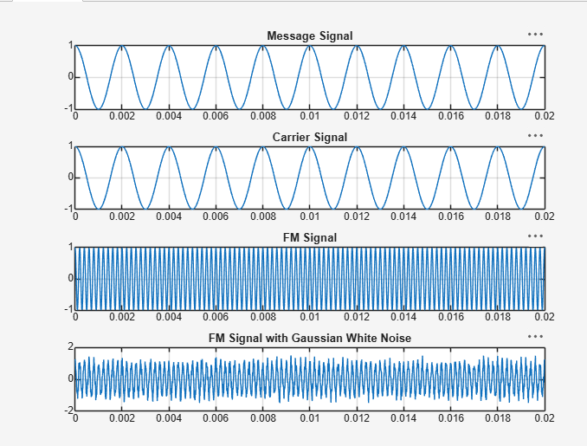
Result:
1. Generated and visualized an FM signal using specified carrier and message signal parameters.
2. Introduced AWGN into the FM signal at a specified signal-to-noise ratio (SNR).
3. Compared clean and noisy FM signals in the time domain.
4. Computed the FFT and compare the frequency-domain characteristics of the clean and noisy FM signals.
5. Evaluated the influence of AWGN on the quality and spectral characteristics of the transmitted FM signal.

